**CS4099 Research**

**Ultracane**

1)electronic long white cane for use by people who are blind or visually impaired- helps users avoid obstacles and navigate around them. In forward path and head-chest level. Done through tactile feedback through vibrating buttons

2) The tactile nature makes it easy to use and carry, as its pretty much like a normal cane. Although it might take a bit of time to get used to, once you are ok to use it, it becomes second nature due to the use of other senses. would it still work in the rain? Could add functionality that would deal with an instance where the user might fall or injure themselves…maybe call 999. Could do more on detecting surfaces and holes in them.

3)narrow beam sensors- ultrasonic waves from 2 sensors are emitted – like bats ultrasound.

4) I liked the aspect of using ultrasounds sensors to create a map of the location- kind of like echo location.

Impact on sensors

2 sensors working at the same times

Detecting floor type- microphone or acclorometer

**Envision Glasses**

1. Translates everyday visual information into speech, recognises faces and colours.
2. *The glasses are lightweight, which makes it easier to carry and use and more convenient. Will soon forgets its even there(unobstructive).

*How does it manage information overload-for example when at a funfair, could it be overwhelming.

*Privacy is concern.

*Reads hand writings as well as texts which is very useful as well as colour recognition.

*Maybe a bit too many features, making it seem like a smart watch or a mobile phone rather than a object that does one thing very well so makes usability a lot harder especially for older people.

Storing data form camera as security and privacy concern

3)camera, direct speaker

4)The text to speech and colour detection seems very interesting but I am not sure how usable the cane would be once we have an earphone. We might need to consider a speaker. As discussed with steven the colour detection is extremely useful. But must remain simple and usable.

**Sunu-Band**

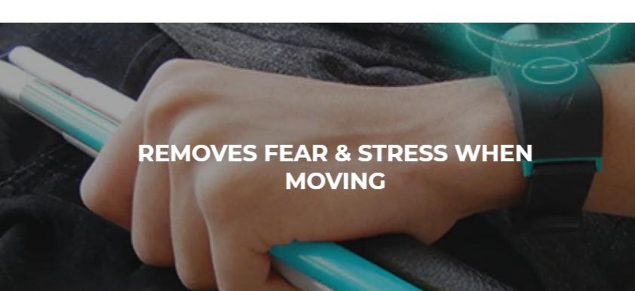

1. A wristband wore by the visually impaired to complement their walking stick. It helps to perceive people and obstacles through vibration
2. Only works for upper body, which is not picked up by the walking stick

*Easy to use and carry as it’s a wristband

*Could pair the band to app to give more features so its basic use is segregated from its advance use, which gives users more flexibility

*The gps is very useful as it gives the person somewhat of an idea what is going to appear next.

* I would improve on the speaker as it is not very useful in a noisy setting and could disturbed other people in a silent setting making the user feel self-conscious about getting unwanted attention.

1. Using echo location using ultrasound sensors. Vibrating motors speakers. GPS sensors. Camera
2. Would look at giving the user something more than just vibration and haptic feedback so some audio. This would make the learning curve a lot easier. This feature should be able to be turned off if the user wishes
3. what functionality has been achieved
4. how well have they been achieved, anything you think can improve on if you are interested in this aspect
5. what sensors have been used
6. what's your own interest and objectives?

Camera

Object tracking and obstacle detection

Finding objects user wants to find

User gyro and accl to make object detection more robust

Find and navigate the product

Create repo for code and diss

Radar camera,acc/gyr, microphone

DOER